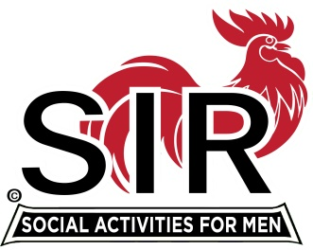
Las Trampas Branch 116
BEC Meeting Agenda
June 21, 2021, 8:30 AM
The Mission of SIR is to enhance the lives of our members through fun activities, events and luncheons – while making friends for life.

8:30 am Call to order; Secretary confirm a quorum

8:35 Secretary –Paul Ramacciotti – Approval of May 17 and May 27, 2021 minutes

8:40 Treasurer –/Alan Fitzgerald – Report

8:45 Standing Reports
- Membership – Phil Goff
- RAMP Department Head Reports:
- Recruitment
- Activity Coordinator
- Member relations
- Publicity
- Covid Compliance [Kevin Donahue]

9:00 Big SIR Report – Sam Beret

- June 21 monthly meeting agenda
2. Form “Restart Committee”:
a- Guidance from State SIR
b- “pre_Restart_Celebration_Party” - who/when/where?
c- Boundary Oak considerations:
no capacity limitations?
Masks?
Price?
Who/when?
d- Communication with members for the announcement:
Headcount? Phone tree for those who do not read email?
By “advanced reservation only”?
e- How do we check for waivers & proof of vaccination? Greeters?
f- Do we accept “credit card payments” for this luncheon? If so, how do we check at registration whether they paid?
g- Speaker – “in-person” or via “Zoom”
h- Greeters - who
i- Chaplain - who
j- Raffle – who
k- Storyteller – who
l- Other

9:45 Little SIR Report - Fred Wachowicz
1. Speaker
2. Birthday Boys
3. Diversity Team Report

9:55 Old Business
New Business

10:15 Adjourn; Next BEC Meeting, July 19, 2021

Join Zoom Meeting Weblink
https://us02web.zoom.us/j/85332344422
Meeting ID: 853 3234 4422
Passcode: 612956
Dial by home phone: (669) 900-9128

